**1)**

SELECT AVG(total_amount_paid) AS average FROM

(SELECT

A.customer_id,

A.first_name,

A.last_name,

D.country as country_name,

C.city,

SUM(E.amount) as total_amount_paid

FROM customer A

INNER JOIN address B ON A.address_id = B.address_id

INNER JOIN city C ON B.city_id = C.city_id

INNER JOIN country D ON C.country_id = D.country_id

INNER JOIN payment E ON A.customer_id = E.customer_id

WHERE city IN ('Aurora', 'Tokat', 'Tarsus', 'Altixco', 'Emeishan', 'Pontainak', 'Shimoga', 'Aparaceida de Goiania', 'Zalantun', 'Taguig')

GROUP BY

A.customer_id,

D.country,

C.city

ORDER BY total_amount_paid DESC

LIMIT 5) AS all_customer_count

Output



**2)**

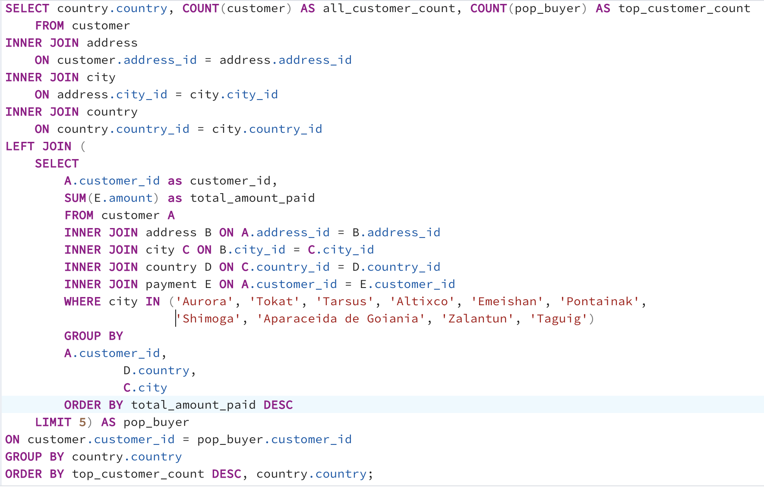

Query as text:

SELECT country.country, COUNT(customer) AS all_customer_count, COUNT(pop_buyer) AS top_customer_count

FROM customer

INNER JOIN address

ON customer.address_id = address.address_id

INNER JOIN city

ON address.city_id = city.city_id

INNER JOIN country

ON country.country_id = city.country_id

LEFT JOIN (

SELECT

A.customer_id as customer_id,

SUM(E.amount) as total_amount_paid

FROM customer A

INNER JOIN address B ON A.address_id = B.address_id

INNER JOIN city C ON B.city_id = C.city_id

INNER JOIN country D ON C.country_id = D.country_id

INNER JOIN payment E ON A.customer_id = E.customer_id

WHERE city IN ('Aurora', 'Tokat', 'Tarsus', 'Altixco', 'Emeishan', 'Pontainak', 'Shimoga', 'Aparaceida de Goiania', 'Zalantun', 'Taguig')

GROUP BY

A.customer_id,

D.country,

C.city

ORDER BY total_amount_paid DESC

LIMIT 5) AS pop_buyer

ON customer.customer_id = pop_buyer.customer_id

GROUP BY country.country

ORDER BY top_customer_count DESC, country.country;

Output:

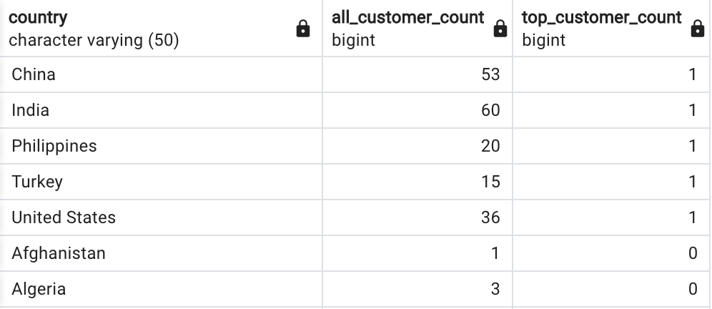

……. every single country

**3)**

I believe it could have been done, but the performance would have suffered. One would have needed to conduct numerous queries, determine which country one of the top five citizens resides in, etc. In conclusion, it wouldn't make much sense to accomplish this without subqueries.

They are helpful if you want to extract various information from the same data or data that has a connection point, which typically requires combining multiple searches manually.

EXPLAIN SELECT country.country, COUNT(customer) AS all_customer_count,COUNT(pop_buyer) AS top_customer_count FROM customer INNER JOIN address ON customer.address_id = address.address_id INNER JOIN city ON address.city_id = city.city_id INNER JOIN country ON country.country_id = city.country_id LEFT JOIN (SELECT A.customer_id as customer_id,SUM(E.amount) as total_amount_paid FROM customer A INNER JOIN address B ON A.address_id = B.address_id INNER JOIN city C ON B.city_id = C.city_id INNER JOIN country D ON C.country_id = D.country_id INNER JOIN payment E ON A.customer_id = E.customer_id WHERE city IN ('Aurora', 'Tokat', 'Tarsus', 'Altixco', 'Emeishan', 'Pontainak', 'Shimoga','Aparaceida de Goiania', 'Zalantun', 'Taguig') GROUP BY A.customer_id,D.country, C.city ORDER BY total_amount_paid DESC LIMIT 5) AS pop_buyer ON customer.customer_id = pop_buyer.customer_id GROUP BY country.country ORDER BY top_customer_count DESC, country.country;